EX 29:MERGE TWO LIST
#include <stdio.h>

int main() {
int a[100], b[100], c[200];
int n1, n2, i, j;

// Input size of first list
printf("Enter size of first list: ");
scanf("%d", &n1);

// Input elements of first list
printf("Enter %d elements of first list:\n", n1);
for (i = 0; i < n1; i++) {
scanf("%d", &a[i]);
}

// Input size of second list
printf("Enter size of second list: ");
scanf("%d", &n2);

// Input elements of second list
printf("Enter %d elements of second list:\n", n2);
for (i = 0; i < n2; i++) {
scanf("%d", &b[i]);
}

// Merge the lists
for (i = 0; i < n1; i++) {
c[i] = a[i];
}
for (j = 0; j < n2; j++) {
c[i + j] = b[j];
}

// Output merged list
printf("\nMerged List:\n");
for (i = 0; i < n1 + n2; i++) {
printf("%d ", c[i]);
}

return 0;
}
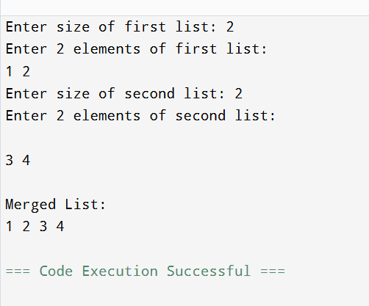
EX 30:GRAPH FOR SHORTEST PATH
#include <stdio.h>
#include <stdlib.h>

#define MAX 100

int queue[MAX], front = -1, rear = -1;
int visited[MAX], distanceArr[MAX];

void enqueue(int x) {
if (rear == MAX - 1) return;
if (front == -1) front = 0;
queue[++rear] = x;
}

int dequeue() {
if (front == -1) return -1;
int x = queue[front];
if (front == rear) front = rear = -1;
else front++;
return x;
}

void shortestPath(int graph[MAX][MAX], int n, int start, int end) {
for (int i = 0; i < n; i++) {
visited[i] = 0;
distanceArr[i] = -1;
}

enqueue(start);
visited[start] = 1;
distanceArr[start] = 0;

while (front != -1) {
int node = dequeue();

for (int i = 0; i < n; i++) {
if (graph[node][i] == 1 && !visited[i]) {
visited[i] = 1;
distanceArr[i] = distanceArr[node] + 1;
enqueue(i);

if (i == end) return;
}
}
}
}

int main() {
int n = 6;

// Graph (Adjacency Matrix)
int graph[MAX][MAX] = {
{0,1,1,0,0,0},
{1,0,0,1,0,0},
{1,0,0,1,1,0},
{0,1,1,0,0,0},
{0,0,1,0,0,1},
{0,0,0,0,1,0}
};

int start = 0; // Node 1
int end = 4; // Node 5

shortestPath(graph, n, start, end);

printf("Shortest Path from %d to %d is: %d edges\n",
start + 1, end + 1, distanceArr[end]);

return 0;
}
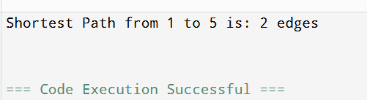
EX 31:TSP IN C WITH OUTPUT
#include <stdio.h>
#include <limits.h>

int graph[10][10];
int visited[10];
int n, finalCost = INT_MAX;
int path[10], finalPath[10];

void tsp(int city, int count, int cost) {
if (count == n && graph[city][0] > 0) {
int totalCost = cost + graph[city][0];

if (totalCost < finalCost) {
finalCost = totalCost;
for (int i = 0; i < n; i++)
finalPath[i] = path[i];
}
return;
}

for (int i = 0; i < n; i++) {
if (!visited[i] && graph[city][i] > 0) {
visited[i] = 1;
path[count] = i;

tsp(i, count + 1, cost + graph[city][i]);

visited[i] = 0;
}
}
}

int main() {
printf("Enter number of cities: ");
scanf("%d", &n);

printf("Enter cost matrix:\n");
for (int i = 0; i < n; i++) {
for (int j = 0; j < n; j++) {
scanf("%d", &graph[i][j]);
}
}

visited[0] = 1;
path[0] = 0;

tsp(0, 1, 0);

printf("\nMinimum cost: %d\n", finalCost);
printf("Path: ");
for (int i = 0; i < n; i++)
printf("%d -> ", finalPath[i]);
printf("0\n");

return 0;
}
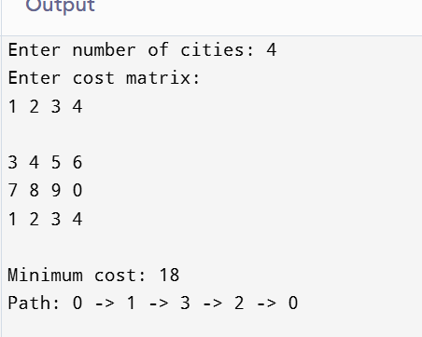
EX 32:TREE TRAVERSAL
#include <stdio.h>
#include <stdlib.h>

struct Node {
int data;
struct Node* left;
struct Node* right;
};

struct Node* createNode(int data) {
struct Node* newNode = (struct Node*)malloc(sizeof(struct Node));
newNode->data = data;
newNode->left = newNode->right = NULL;
return newNode;
}

struct Node* insert(struct Node* root, int data) {
if (root == NULL)
return createNode(data);

if (data < root->data)
root->left = insert(root->left, data);
else
root->right = insert(root->right, data);

return root;
}

void inorder(struct Node* root) {
if (root == NULL) return;
inorder(root->left);
printf("%d ", root->data);
inorder(root->right);
}

void preorder(struct Node* root) {
if (root == NULL) return;
printf("%d ", root->data);
preorder(root->left);
preorder(root->right);
}

void postorder(struct Node* root) {
if (root == NULL) return;
postorder(root->left);
postorder(root->right);
printf("%d ", root->data);
}

int main() {
struct Node* root = NULL;
int n, value;

printf("Enter number of nodes: ");
scanf("%d", &n);

printf("Enter %d values:\n", n);
for (int i = 0; i < n; i++) {
scanf("%d", &value);
root = insert(root, value);
}

printf("\nInorder Traversal: ");
inorder(root);

printf("\nPreorder Traversal: ");
preorder(root);

printf("\nPostorder Traversal: ");
postorder(root);

return 0;
}
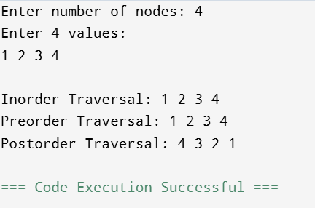
EX 33:
STACK
#include <stdio.h>
#define SIZE 5

int stack[SIZE], top = -1;

void push(int x) {
if (top == SIZE - 1)
printf("Stack Overflow!\n");
else {
stack[++top] = x;
printf("%d pushed\n", x);
}
}

void pop() {
if (top == -1)
printf("Stack Underflow!\n");
else
printf("%d popped\n", stack[top--]);
}

void display() {
if (top == -1)
printf("Stack is empty\n");
else {
printf("Stack elements: ");
for (int i = top; i >= 0; i--)
printf("%d ", stack[i]);
printf("\n");
}
}

int main() {
push(10);
push(20);
push(30);
display();
pop();
display();
return 0;
}
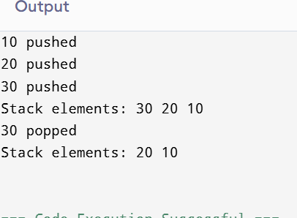
EX 34:HASHING
#include <stdio.h>

int main() {
int hash[10];
int size = 10;
int n, value, index;

// Initialize hash table
for (int i = 0; i < size; i++)
hash[i] = -1;

printf("Enter number of elements to insert: ");
scanf("%d", &n);

printf("Enter %d values:\n", n);
for (int i = 0; i < n; i++) {
scanf("%d", &value);

index = value % size; // Hash function

// Linear probing
while (hash[index] != -1)
index = (index + 1) % size;

hash[index] = value;
}

// Display hash table
printf("\nHash Table:\n");
for (int i = 0; i < size; i++)
printf("Index %d --> %d\n", i, hash[i]);

return 0;
}
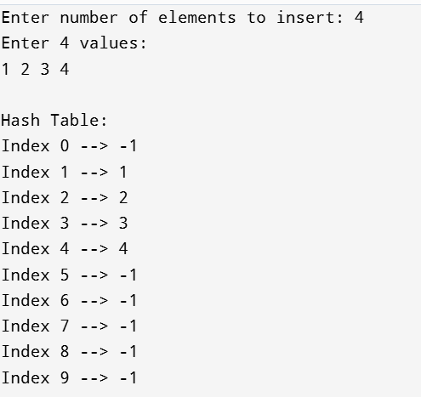
EX 35:QUICK SORT
#include <stdio.h>

void swap(int *a, int *b) {
int temp = *a;
*a = *b;
*b = temp;
}

int partition(int arr[], int low, int high) {
int pivot = arr[high];
int i = low - 1;

for (int j = low; j < high; j++) {
if (arr[j] < pivot) {
i++;
swap(&arr[i], &arr[j]);
}
}

swap(&arr[i + 1], &arr[high]);
return i + 1;
}

void quickSort(int arr[], int low, int high) {
if (low < high) {
int pi = partition(arr, low, high);

quickSort(arr, low, pi - 1);
quickSort(arr, pi + 1, high);
}
}

int main() {
int arr[6] = {50, 20, 40, 70, 10, 30};
int n = 6;

printf("Original Array: ");
for (int i = 0; i < n; i++)
printf("%d ", arr[i]);

quickSort(arr, 0, n - 1);

printf("\nSorted Array: ");
for (int i = 0; i < n; i++)
printf("%d ", arr[i]);

return 0;
}
